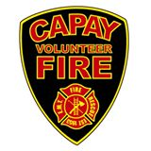
Capay Fire Protection District

50 Fourth Avenue
Orland, CA 95963

MEETING AGENDA
February 8, 2022
7:00 p.m.

- Call To Order

- Flag Salute

- Roll Call

- Public Comment

- Minutes of the Previous Meeting – December 14, 2021

- Bills

- Chief’s Report

- Lori’s Minute

9. Old Business

  - Clark Avenue Water Supply
  - AFG Grant MOU

- New Business
  - Audit Review

- Closed Session
- Board Member Discussions

Next Meeting – March 8, 2022 @ 7 p.m.

